TEAM 2 – WELLNESS WARRIORS
GLAM DATASET CLEANING AND TRANSFORMATION REPORT
PROJECT CONTEXT: GLAM MATERNITY DATASET ANALYSIS
DATA SOURCE :
https://drive.google.com/drive/folders/1bJtY8vR6Xij7rgd5E4pKt2YoA9h9JBKq?usp=sharing
TOOLS USED: POWER BI (POWER QUERY EDITOR), DAX Studio
SPRINT 1: DATA CLEANING AND TRANSFORMATION
DATASET OVERVIEW:
The GLAM (Glucose levels across maternity) study is an observational, noninterventional investigation designed to assess glucose patterns in pregnant women using blinded continuous glucose monitoring (CGM). It aims to explore how CGM-measured dysglycemia correlates with oral glucose tolerance test (OGTT) results and adverse pregnancy outcomes (APOs).
DATA CLEANING:
- This report outlines the data cleaning process for the CGM monitoring dataset used in the GLAM dashboard.
- The original data contained schema mismatches, placeholder values, nulls, and ambiguous timestamps.
- Column names, formats, and encodings varied across sources, potentially causing ingestion errors or mismatched joins. Fields sometimes included synonyms, inconsistent casing, or non-informative values, complicating analysis.
- Cleaning was performed to ensure traceable ingestion, modular transformation, and stakeholder-ready export. Cleaned datasets can be exported via DAX Studio ensuring reproducibility and usability for downstream reporting and analytics.
DATA EXTRACTION:
Workflow Identification: Reasoning
After Brainstorming and deciding the tool to be used, we decided the Workflow because we have provided with 16 .txt docs with “|” as a delimiter. So, uploading each doc manually and cleaning would not be the efficient manner of staging, so we decided to go with “Folder Upload + Transform”.
Advantage: Folder Upload for Staging and Referencing for Split the Dimension Tables.
- One Time Setup for all the files.
- Auto loads when new files are uploaded.
- Transformation of basic logic will be centralized (Only once)
- Dynamic Refresh would be easier in Folder updates.
So, the workflow would be Folder upload🡪Reference Queries🡪Add as aNew Query🡪Transform Each Table🡪Data Model🡪Dax & Visualization.
Folder Upload Challenges:
As all 16 .txt documents have different schema Folder upload + Combine won’t help.
So instead of Combine and Transform we directly loaded the data files.
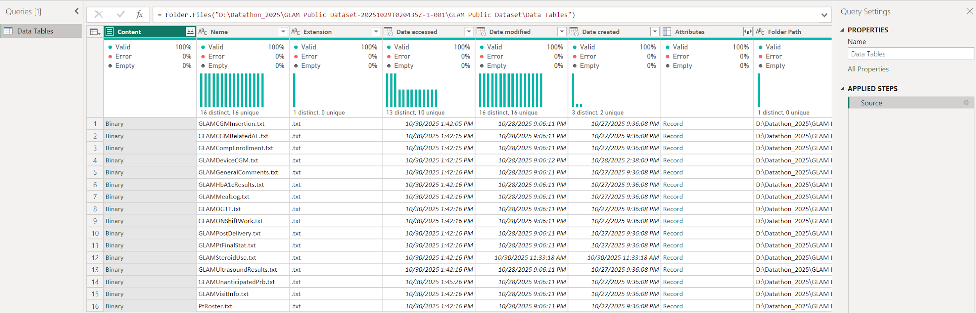
CREATING A CENTRALIZED FOLDER PATH FOR LOADING THE DATA:
The centralized path was created to ensure consistent data access across users. When one user loads the tables, others may encounter broken links due to differing local file paths. By defining a parameterized Folder Path, we enabled dynamic path resolution which allows every user to access the data by updating a single, shared parameter instead of modifying each query individually.
Centralized Folder Path Strategy for Scalable Ingestion:
we implemented a Centralized Parameter named "Folder Path". This parameter is directly linked to the Base Query, which serves as the foundational reference for all subsequent table queries.
By referencing the base query in each table, we ensure that the centralized folder path is automatically inherited across all queries. This design allows us to update the file path once, within the centralized parameter and have that change propagate throughout the entire ingestion pipeline.
Benefits of This Approach:
- Modular and Scalable: Supports ingestion of multiple files without repetitive edits
- Error-Proof: Reduces risk of broken links or mismatched paths
- Time-Saving: One-time update applies globally across all referenced tables.

STEPS TO CREATE THE PARAMETER:
- Transform Data-->Manage Parameter-->New Parameter-->Folder Path-->Click OK.
- Open Base query-->Advanced Editor-->Change the hard coded file path to "Folder Path"
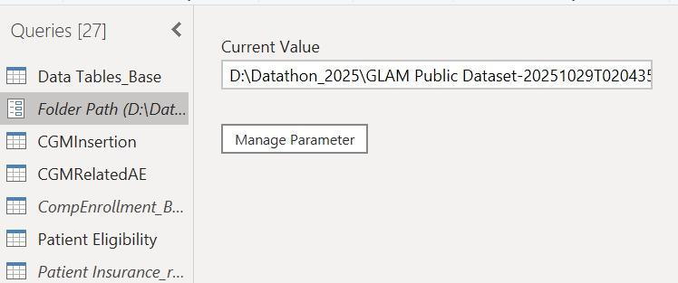

DATA CLEANING STEPS:
  - Sorted the patient id (key constraint column) in ascending order for all the tables.
  - Renamed the column names to appropriate meaningful names for better readability.
  - Decomposed complex tables into smaller, structured tables to enhance data analysis and visualization efficiency.
  - Removed some of the columns which were redundant and not helpful for data analysis.
  - Date inconsistencies were fixed in all the tables. (DATE format and DATETIME based on the requirement)
  - Replaced all the flags with Yes/No instead of 0 and 1 uniformly through the dataset.
  - Merged some of the flagged columns into one column which had reasons for medical conditions.
  - Merged the time series columns which had hour and min data into one column as TIME format.
  - Rounded off some decimal valued columns.
  - Ensured all the columns are in appropriate datatype.
  - To build the Fact Table PatientRoster, columns Visit, VisitDt and VisitVirtual from the VisitInfo table and Ethnicity, Race and EducationalLevel from the Demography table, all merged with the PatientRoster to enrich each record with visit and demographic context.
  - Disabled the load for the following queries in Power BI:CompEnrollment,Patient Insurance,PostDelivery,UnanticipatedPrb,VisitInfo

DATA TABLES:
Table : CGMRelatedAE
Renamed/Generated Column Name:Adverse Skin Events
Cleaning Steps: Merged the following 7 columns into one SkinRedness,SkinSwelling,Skin Pain,SkinBruising,SkinBleeding,SkinInfection,SkinOth - Removed these columns
Method Used: Text. Combine merges non-null labels into a comma-separated string, and Text. Length returns null for empty strings to avoid blank outputs.

Table : GLAMCompEnrollment was decomposed into smaller structured tables
Below are the table names.
Patient Eligibility, Patient Insurance, PCOS, Pregnancy Info, Medical History1, Medical History2.
Table : PCOS
Renamed/Generated Column Name:PCOSMedicine1DiscMon/Year,PCOSMedicine2DiscMon/Year,PCOSMedicine3DiscMon/Year,
Cleaning Steps:Merged the columns PCOSMedDiscMon1,PCOSMedDiscYr1,PCOSMedDiscMon2,PCOSMedDiscYr2,PCOSMedDiscMon3,PCOSMedDiscYr3
Method Used: Date.ToText function checks if both month and year are present, then builds and formats a readable date like "Jan 2023"; otherwise, it returns null.
Table : MedicalHistory2
Renamed/Generated Column Name:GDMTreatmentMethod
Cleaning Steps:Merged the Columns,GDMInsulin,GDMMetformin,GDMDiet,GDMExercise
Method Used: Text.Combine merges non-null labels into a comma-separated string, and Text. Length returns null for empty strings to avoid blank outputs

Renamed/Generated Column Name:ChronHypertensionDiagMon/Year
Cleaning Steps:Merged the Columns ChronHyperDiagMon,ChronHyperDiagYear
Method Used: Checked if both month and year are present, then builds and formats a readable date like "Jan 2023"; otherwise, it returns null.

Renamed/Generated Column Name:ChronicHypertensionTreatmentMethod
Cleaning Steps:Merged the Columns CalChanBlock,BetaBlock,Diuretic,Combination,Other
Method Used: Text.Combine merges non-null labels into a comma-separated string, and Text. Length returns null for empty strings to avoid blank outputs

Table :OGTT has multiple time series columns with hour and minutes separately. So we merged all those into one single column with TIME Format. Newly created columns are ZeroHourBloodDraw, ZeroHourBloodDraw, Hour2BloodDraw, Hour3BlloodDraw.

Table : Patient Delivery Info
Renamed/Generated Column Name:GDMTreatmentType
Cleaning Steps:Merged the Columns GDMTrtInsulin,GDMTrtMetformin,GDMTrtDiet,GDMTrtExercise,GDMTrtOtherDs
Renamed/Generated Column Name:SysHighBldPrTime, DiaHighBldPrTime
Cleaning Steps:Merged the Columns SysHighBldPrHr, SysHighBldPrMin, SysHighBldPrHr, SysHighBldPrMin
Renamed/Generated Column Name:PEC/GHTNSystolicLinkedTime, PEC/GHTNDiastolicLinkedTime
Cleaning Steps:Merged the Columns PECSysHighBldPrHr, PECSysHighBldPrMin, PECDiaHighBldPrHr, PECDiaHighBldPrMin
Renamed/Generated Column Name:PregEndReason
Cleaning Steps:Merged the Columns PregEndChromo, PregEndCong , PregEndSpon, PregEndIntra, PregEndTerm , PregEndUnk, PregEndOther
Renamed/Generated Column Name:LaborCSecTime, OnsetLaborDeliveryTime
Cleaning Steps:Merged the Columns LaborHr, LaborMin, DeliveryHr, DeliveryMin
Renamed/Generated Column Name:LaborInductionReasons
Cleaning Steps:Merged the Columns InducElec, InducIUFD, InducAnom, InducIUGR, InducOligoPregEndReason,InducFStat,InducAbrupt,InducHyper,InducPreeclamp,InducGDM,InduceChorio,InducePROM,InduceObes,InduceMedCond,InduceMacro,InducePostTerm,InduceCholes,InducePolyhy,InduceOther

Table : Infant Info
Renamed/Generated Column Name:Infant Anomaly
Cleaning Steps:Merged the Columns,CAAscites,CAPericardial,CAHydrocephalus,CAMyocarditis,CABowelObst,CARenal,CAAnencephaly,CAMMC,CACCHD,CACDH,CAOmphalocele,CAGastroschisis,CALRE,CACleftLip,CACleftPalate,CADownSyndrome,CAChromoDisorder,CAHypospadias,CAAGMaleGeno,CAAGFemaleGeno,CAVSD,CAPostPoly,CAOther
Renamed/Generated Column Name:BirthInjuryTypes
Cleaning Steps:Merged the columns InjSpine,InjSkullFracture,InjClaviFracture,InjHemorrhage,InjNerve,InjOther
Renamed/Generated Column Name:NeoTreatmentType
Cleaning Steps:Merged the columns NeoHypoTreatOral,NeoHypoTreatIV

Table : PatientWithdrawalInfo
Renamed/Generated Column Name:WithdrawalAdditionalReason
Cleaning Steps:Merged the columns PtWithdrawAE,PtWithdrawChgDr,PtWithdrawNotCont,PtWithdrawMoved,PtWithdrawSched,PtWithdrawTravDiff,PtWithdrawVisLen,PtWithdrawUnk,PtWithdrawOth

Exporting Cleaned Data as CSVs:
- Saved the final cleaned model in Power BI after applying all necessary transformations and schema validations.
- Connected to the Power BI data model using DAX Studio for direct access to optimized tables.
- Exported all cleaned tables at once as Comma Separated Value (CSV) files using DAX Studio’s batch export feature.
- Saved the CSVs into a centralized folder, ensuring consistent access and traceability for all users.
- The exported datasets are now ready for analysis and visualization, with clean structure and formatting across all files.

